- Bluebook Page50 August 2019 Variant Three examination:

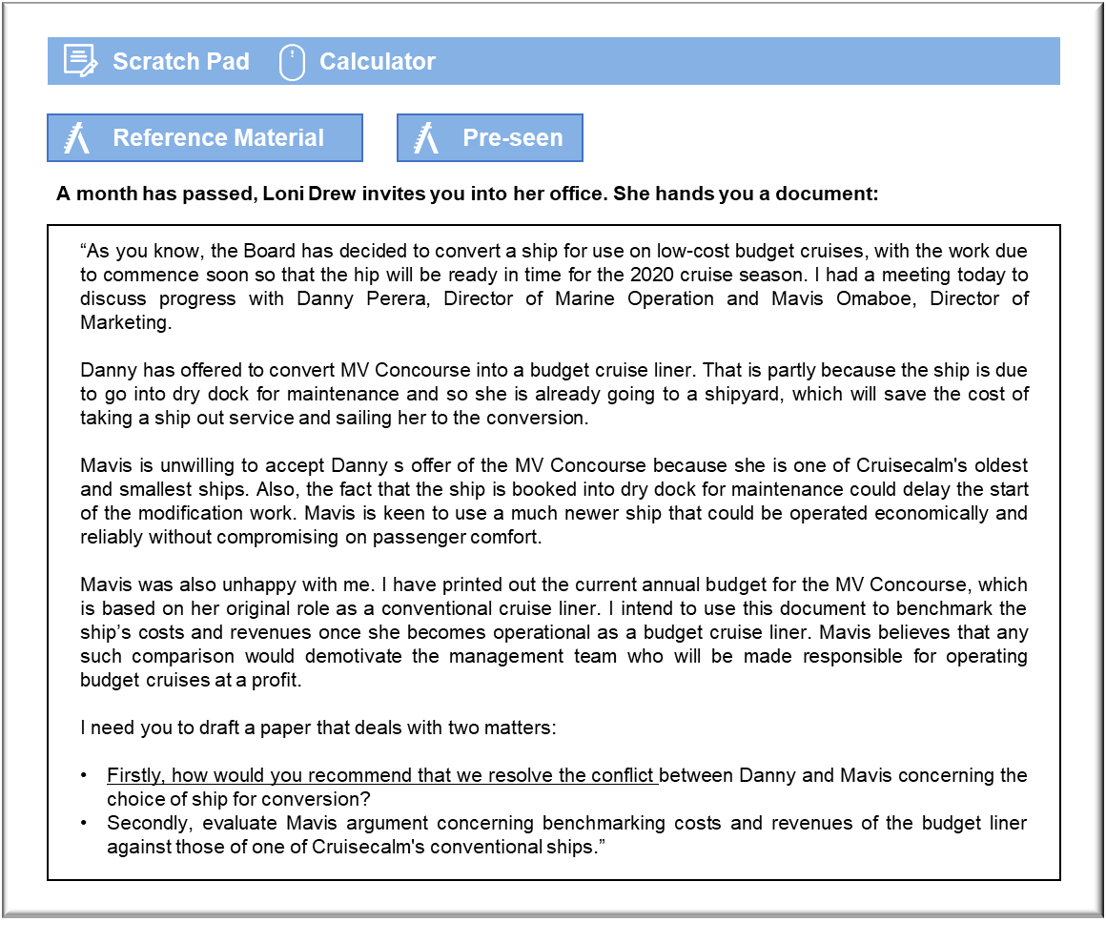

MANAGEMENT CASE STUDY AUGUST 2019 EXAM ANSWERS

Variant3 Task3
These answers have been provided by CIMA for information purposes only. The answers created are indicative of a response that could be given by a good candidate. They are not to be considered exhaustive, and other appropriate relevant responses would receive credit.

CIMA will not accept challenges to these answers on the basis of academic judgement.

Requirement 1: Resolving conflict
We need to start by investigating the reason for this conflict. Hopefully, the conflict is attributable to the two directors having a different perception of the business issues associated with the choice of ship. It may be that there are personal disagreements between Danny and Mavis, which could be far more difficult to identify and resolve. As a starting point, it would make sense to have a third director meet with both Danny and Mavis and ask them to explain their concerns, with a view to seeking a response that is in Cruisecalm’s overall best interests.
Once the basis of the conflict has been identified, we need to accept that the two directors will be protective of their respective functional areas. Marine Operations is responsible for providing the ships with which to service the many cruises that Cruisecalm has committed itself to providing and Marketing must sell places on the new budget venture. That suggests that it might be preferable to involve the whole Board in the final decision, with the trade-offs between objectives being considered from the company’s point of view.
The conflict between Danny and Mavis appears to involve low co-cooperativeness and high
assertiveness, which makes it difficult to reach an optimal consensus. That generates the sense of competition that manifests itself in both attempting to maximise their respective interests. That could lead to ongoing problems between the two directors, regardless of how the conflict over the ship is resolved.
Ideally, the Board as a whole will manage to eliminate the cause of this conflict by clarifying the respective responsibilities of the two directors so that the conflict is resolved. For example, it could be made clear to Danny that Marine Operations is responsible for ensuring that all 15 ships are available to meet their respective commitments and that it makes no difference whether any given ship is being used for low-cost or traditional cruises. In the same vein, it could be put to Mavis that Marketing’s sales targets will take full account of the size and quality of the ship that is converted for this purpose, which could reduce the attractiveness of the newer and larger ships.

Requirement 2: Benchmarking
This new venture will have a high profile, both within Cruisecalm and externally. It is natural that Mavis will be nervous about the manner in which her performance will be measured. It will be potentially difficult to achieve targets that have been set in comparison with the existing business.
For example, the fact that fares will be lower would mean that Marketing would have to aim for higher occupancy rates in order to achieve comparable revenues to a ship offering conventional cruises. Operating costs may also prove difficult to manage, given that the need to make savings will have to be set against the need to give the passengers value for money so that they give positive feedback. There are relatively few areas in which costs can be reduced and excessive savings, such as serving very cheap food, will make the passenger experience unpleasant.
It could be argued that Mavis’ arguments are slightly self-serving and irrelevant at this stage. For example, there is very little point in offering low-cost cruises unless Cruisecalm can make a profit from them. Some costs will be the same for a low-cost cruise as for the existing cruises. For example, all ships require the same number of deck and engineering staff, regardless of the type of cruise being offered. Cruisecalm’s Board must be able to determine whether the low-cost model is a viable alternative to the more upmarket cruises that are already on offer.
Benchmarking costs and revenues in the proposed manner will make it easier for the Board to understand whether the new venture is viable.
Mavis’ staff should also be realistic about the nature of the product that is being offered. The MV Concourse will be modified slightly so that only buffet meals will be provided. Cruisecalm already sells cruises on the basis that passengers can opt to eat in buffet restaurants. The sales staff are already experienced at selling cruises that feature this dining option and so they have no reason to be demoralised. It would be useful to benchmark operating costs and revenues as proposed, August 2019 6 Management Case Study Exam provided the targets are realistic and allow for the nature of the cruises that are being offered. It should also be possible to reassure Marketing staff that their performance will be reviewed in the light of experience and that full account will be taken of any problems that arose due to the design and implementation of the low-cost cruises.

